MOUNT KENYA UNIVERSITY

SCHOOL OF COMPUTING AND INFORMATICS

DEPARTMENT OF INFORMATION TECHNOLOGY for (BSCCS)

BY: STEVE CASCALEN OTIENO

Reg. No: BSCCS/2022/52464

PROJECT TITLE: SMART STUDY ASSISTANT AI

This project proposal submitted in partial fulfilment of requirement for the Mount Kenya

University award of BACHELOR OF __________________________________

# DECLARATION PAGE

DECLARATION

I hereby declare that this project report is based on my original work except for citations and quotations

which have been duly acknowledged. I also declare that it has not been previously and concurrently

submitted for any other degree or award at Mount Kenya University

Signature: _________________________

Name: _________________________

REG.No: _________________________

Date: _________________________

SUPERVISOR

I the undersigned do hereby certify that this is a true report for the project undertaken by the above

named student under my supervision and that it has been submitted to Mount Kenya University with my approval

# Signature……………………………………………………. Date……………

# DEDICATION

This work is dedicated to my loving family, whose encouragement and unwavering support gave me the strength to pursue this project. To my friends and colleagues, for their constant motivation, and to my supervisor, for their guidance and wisdom throughout this journey. Above all, I dedicate this project to all learners who continue to seek knowledge and innovation, as it is for their growth and empowerment that Smart Study was built.

# Abstract

Smart Study is a Django-based web application that integrates state-of-the-art Large Language Models (LLMs) via Together APIs to deliver a seamless AI-first learning experience. The system offers: (1) a Notes Summarizer for concise topic overviews, (2) a Quiz Generator that creates auto-graded quizzes from notes (3) (4) a Homework Chatbot that guides students through problem-solving steps without revealing final answers when pedagogically inappropriate, and (5) secure authentication (signup/signin). We present the motivation, methodology, system architecture, implementation, evaluation metrics, and results, concluding with limitations and recommendations.

**Keywords:** AI in education, LLM, Together API, Django, quiz generation, summarization, language learning, educational technology.

Contents

DECLARATION PAGE 2

Signature……………………………………………………. Date…………… 2

DEDICATION 3

Abstract 3

1. Chapter One 7

**1.1 Background** 7

1.2 Problem Statement 9

**1.3 Proposed Solution** 9

**1.4 Project Title** 10

**1.5 Project Objectives** 11

**1.6 Project Scope** 12

1.7 Project Justification/Significance 13

**1.8 Project Risks and Mitigation** 13

**1.8.1 Technical Risks** 13

**1.8.2 Operational Risks** 13

**1.8.3 Project Management Risks** 14

**1.9 Project Cost** 14

**CHAPTER TWO: LITERATURE REVIEW** 16

**2.1 Introduction** 16

**2.2 Summarization Techniques: Extractive vs. Abstractive** 16

**2.3 Automated Question Generation (QG) and Bloom’s Taxonomy** 16

**2.4 Conversational Tutoring and Scaffolding** 17

17

**2.5 Prompt-Engineering Best Practices** 17

**2.6 Ethical AI in Education** 17

**2.7 Synthesis and Research Gaps** 18

Chapter 3 Methodology & System Design 19

3.1 System Overview 19

3.2 High-Level Architecture 19

3.3 Data Flow 19

Figure 2: DFD 20

3.4 ER Diagram (Entities & Relationships) 20

3.5 Sequence Diagram – Quiz Generation 20

Figure 4: Sequence Diagram 21

3.6 Technology Stack 21

3.7 Risk Management & Ethics 21

**CHAPTER FOUR: SYSTEM ANALYSIS AND REQUIREMENT MODELLING** 22

**4.1 INTRODUCTION** 22

**4.2 SYSTEM FUNCTIONALITY** 22

**4.3 USE CASE ANALYSIS** 22

**4.4 DATA FLOW DIAGRAMS (DFDs)** 23

**4.4.1 Level 0 – Context Diagram** 23

**4.4.2 Level 1 – Student Functionalities** 24

**4.4.3 Level 2 – Quiz Generation Process** 24

**4.5 FLOWCHART** 24

**4.6 ENTITY RELATIONSHIP DIAGRAM (ERD)** 25

**4.7 SYSTEM REQUIREMENTS** 26

**4.7.1 Hardware Requirements** 26

**4.7.2 Functional Requirements** 27

**CHAPTER FIVE: SYSTEM DESIGN** 28

**5.1 SYSTEM DESIGN OVERVIEW** 28

**5.1.1 Architectural Style** 28

**5.1.2 Major Modules (Django Apps)** 28

**5.1.3 Technology Stack** 28

**5.1.4 Non-Functional Priorities** 29

**5.2 INTERFACE DESIGN (Django Templates)** 29

**CHAPTER SIX: SYSTEM IMPLEMENTATION** 38

**6.1 Introduction** 38

**6.2 Coding Tools, Programming Languages, and Frameworks** 38

**6.3 Summary** 40

**CHAPTER SEVEN: LIMITATIONS, CONCLUSIONS, AND RECOMMENDATIONS** 41

**7.1 Limitations** 41

**7.2 Conclusion** 42

**7.3 Recommendations** 43

**References** 44

**Table of Figures**

Figure 1 High level Architecture 20

Figure 2: DFD 21

Figure 3 4.4.1 Level 0 – Context Diagram 24

Figure 4 Flowchat 26

Figure 5 ENTITY RELATIONSHIP DIAGRAM (ERD) 27

Figure 6 Dashboard 31

Figure 7 Quiz Generator 31

Figure 8 Notes Summerizer 32

Figure 9 summerizer preferences 32

Figure 10 Homework Assistant 33

Figure 11 Study Planner 34

Figure 12 Analytical Dashbaord 35

Figure 13 Project settings 35

Figure 14 Home work Chatbot 36

# 1. Chapter One

## **1.1 Background**

Artificial Intelligence (AI) in education has advanced far beyond its early stages of simple automation and now plays a transformative role in shaping how students learn and how educators teach. Today, AI technologies provide highly **personalized learning experiences**, adaptive learning pathways tailored to individual strengths and weaknesses, and **real-time feedback mechanisms** that support diverse groups of learners across different subjects and levels of study. Rather than merely acting as background tools, modern AI systems function as **intelligent tutors**, **dynamic content creators**, and **powerful engines for learning analytics**, enabling both students and instructors to achieve deeper engagement and more measurable learning outcomes.

Smart Study represents a next-generation application of these capabilities by leveraging advanced **Large Language Models (LLMs)** through Together APIs to create a comprehensive and sup Vportive self-study environment. The platform goes beyond surface-level assistance by **transforming raw, unorganized notes into structured, accurate, and concise summaries** that are easier to review and retain. It also **generates both formative and summative assessments of high quality**, helping learners test their understanding continuously and prepare effectively for formal evaluations. Additionally, Smart Study provides **interactive language learning drills** that strengthen vocabulary, grammar, and comprehension, as well as a **guided homework assistant** designed not to simply deliver answers, but to encourage problem-solving skills, critical thinking, and independent reasoning.

In addition to these features, Smart Study extends its functionality with **multilingual support**, making learning accessible to students from different linguistic and cultural backgrounds. The system offers **customizable learning modules** that can be tailored to specific subjects, courses, or skill levels, while also providing **seamless integration with digital classrooms and Learning Management Systems (LMS)**. Its **progress tracking dashboards** empower both learners and educators to monitor performance trends, identify gaps in knowledge, and celebrate improvements over time.

By combining these capabilities, Smart Study aims to **reduce information overload**, close gaps in access to **personalized tutoring**, and build a **scalable, AI-driven educational ecosystem**. This ecosystem not only supports independent study but also fosters collaborative learning and continuous academic growth, ultimately empowering students and educators to thrive in a rapidly evolving knowledge-driven world.

## 1.2 Problem Statement

In today’s fast-paced digital learning environment, learners are increasingly overwhelmed by information overload. With vast amounts of study material scattered across different platforms and formats, students often struggle to extract key points, organize their notes, and focus on what is most important. This leads to reduced comprehension, wasted study time, and difficulty in preparing effectively for exams.

Additionally, learners face limited opportunities for personalized formative assessment. Traditional education models often rely heavily on standardized testing, which provides little room for continuous feedback or adaptive questioning. Without tailored practice questions and instant clarification of doubts, students may develop misconceptions that remain unaddressed. The lack of consistent tutoring support further compounds this issue, leaving many students without timely academic guidance.

Educators, on the other hand, face the challenge of designing and delivering high-quality learning support at scale. Creating question banks manually is time-consuming and prone to inconsistencies. Providing individualized feedback to large groups of learners is impractical, especially when teaching workloads are already high. Moreover, tracking and analyzing student performance across different subjects and tasks can be overwhelming without the aid of intelligent tools.

## **1.3 Proposed Solution**

The **Smart Study System** is designed to leverage Artificial Intelligence and Natural Language Processing (NLP) to transform the traditional self-study experience into an interactive, personalized, and efficient process.

1. **AI-Powered Text Summarization**
   * The system will automatically condense lengthy notes, research papers, and textbooks into concise summaries.
   * This helps students focus on key concepts and saves time during revision.
2. **Homework Assistance Chatbots**
   * Integrated AI chatbots will guide students in solving homework problems by providing hints, explanations, and step-by-step breakdowns rather than direct answers.
   * This encourages understanding rather than memorization.
3. **Automated Question Generation**
   * The platform will analyze uploaded content (class notes, study guides, or textbooks) and generate relevant practice questions (MCQs, short-answer, and essay types).
   * This prepares learners for exams and assessments.
4. **AI-Powered Chat Support**
   * Students can interact with an AI tutor for clarifications, quick answers, or topic explanations.
   * The chatbot adapts to the student’s learning style and difficulty level.
5. **Interactive Dashboard**
   * A simple, intuitive dashboard will allow users to access all functionalities in one place.
   * Features include:
     + Upload study materials
     + View summaries
     + Access practice questions
     + Track study progress and performance
   * The dashboard ensures a smooth learning experience with minimal technical barriers.

## **1.4 Project Title**

Smart Study assistant AI

## **1.5 Project Objectives**

**Personalized Learning Paths**  
Tailor study schedules, resources, and tasks to each learner’s strengths, weaknesses, and pace.

**AI-Powered Summarization**  
Automatically convert long notes, lectures, or textbooks into concise, easy-to-understand summaries.

**Question & Test Generation**  
Generate quizzes, flashcards, and practice tests dynamically from uploaded study material.

**Real-Time Homework Assistance**  
Provide guided solutions, hints, and explanations for assignments while avoiding direct answer-giving.

**Multilingual Learning Support**  
Offer instant translation and content adaptation for learners in different languages.

**AI-Powered Sign Language Support**  
Ensure inclusivity by providing sign language recognition and AI-based interpretation for learners with hearing challenges.

**Study Progress Tracking & Analytics**  
Monitor learner performance, highlight weak areas, and provide detailed reports and progress charts.

**Smart Dashboard & Notifications**  
Centralize all learning tools in one dashboard, with reminders for deadlines, study sessions, and exams.

**Collaboration & Peer Learning**  
Enable group discussions, peer-to-peer Q&A, and shared resources through AI-powered forums/chatbots.

**Adaptive Resource Recommendation**  
Suggest books, videos, research papers, or external materials based on learners’ study goals and performance.

## **1.6 Project Scope**

The **Smart Study Assistant with AI** project is designed to enhance the learning process by offering an intelligent, adaptive, and inclusive study platform. It will be developed as a web-based application, accessible on both desktop and mobile devices, using Django templates to provide a responsive and user-friendly interface.

The central aim of the project is to support students by providing AI-powered tools that simplify studying and make learning more effective. The system will allow learners to create personalized study paths that adapt to their strengths, weaknesses, and goals. Through AI-driven summarization, students will be able to convert lengthy lecture notes, documents, or textbooks into concise summaries that make revision more manageable. In addition, the system will generate quizzes, flashcards, and practice tests from study material, enabling students to engage in interactive self-assessment.

Accessibility is a key priority of this project. To ensure inclusivity, the assistant will incorporate AI-powered sign language recognition and interpretation, making it possible for learners with hearing challenges to benefit from the platform alongside other students.

The platform will feature a smart dashboard where learners can track their progress, analyze performance trends, and receive personalized study recommendations. It will also encourage peer-to-peer interaction by integrating AI-powered chatbots and discussion forums, allowing students to share knowledge, ask questions, and collaborate with others. To enrich the study process further, the assistant will suggest relevant resources such as videos, research papers, or articles that match the learner’s academic needs.

The scope of this project is carefully defined. It will not include multi-language translation, offline desktop applications, certification or accreditation features, or integration with external Learning Management Systems (LMS). Its focus is strictly on delivering tools that directly improve study efficiency and accessibility.

The key stakeholders in this project are students, who will be the primary users, and teachers or lecturers, who can use the system as a supportive tool to complement their teaching methods. The expected deliverables include a functional web-based platform equipped with AI summarization, question and quiz generation, sign language support, progress analytics, collaboration tools, and clear documentation to guide users.

Constraints include the need for a reliable internet connection, sufficient computational resources to run AI models, and an initial limitation where sign language support may focus on one standard system before expanding further.

The project will be executed in phases, starting with requirement analysis and system design, moving on to backend and frontend development, followed by AI model integration, testing, and eventual deployment.

In summary, the Smart Study Assistant with AI is envisioned as a personalized, intelligent, and inclusive platform that empowers learners to study more effectively, collaborate with peers, and gain insights into their academic progress while providing accessibility for students with hearing difficulties.

## 1.7 Project Justification/Significance

Smart Study democratizes personalized learning with pedagogically-aligned AI. Features support learners with diverse needs summarization, quiz generation, language practice, and guided homework chat. Excludes proctoring and full LMS gradebook integration in the initial release. while offering educators insight into progress and misconceptions.

## **1.8 Project Risks and Mitigation**

Like any software development initiative, the Smart Study Assistant with AI project faces several potential risks that could impact its delivery, functionality, or user adoption. Identifying these risks early and defining mitigation strategies is critical to ensure the success of the project.

### **1.8.1 Technical Risks**

* **Risk:** AI models may not produce accurate or reliable summaries, quizzes, or sign language recognition, leading to poor user experience.
* **Mitigation:** Use well-trained, open-source AI/NLP models and perform continuous fine-tuning with real-world data. Conduct pilot testing with students to validate accuracy before full deployment.
* **Risk:** Integration of multiple AI components (summarization, quiz generation, sign language) may create performance bottlenecks.
* **Mitigation:** Optimize code and use efficient APIs. Consider cloud-based AI processing (e.g., GPU-enabled servers) to handle heavy computations.

### **1.8.2 Operational Risks**

* **Risk:** Students may find the system difficult to use or may not adopt it regularly.
* **Mitigation:** Design an intuitive, simple, and responsive user interface. Provide user guides, FAQs, and interactive onboarding tutorials. Gather continuous feedback from students and teachers to improve usability.
* **Risk:** Limited internet connectivity may hinder access to the web-based platform.
* **Mitigation:** Implement lightweight data handling and caching to reduce bandwidth needs. Optimize the platform for mobile devices, since many students rely on mobile internet.

### **1.8.3 Project Management Risks**

* **Risk:** Project timelines may slip due to complexity in AI model integration and testing.
* **Mitigation:** Break down development into clear phases with achievable milestones. Use agile methodology with frequent iterations, testing, and feedback loops.
* **Risk:** Scope creep (adding features beyond the planned scope, e.g., multilingual support or external LMS integration).
* **Mitigation:** Maintain a clear scope definition. Any new features should be deferred to later versions after successful deployment of the core system.

**1.8.4 Security and Privacy Risks**

* **Risk:** Unauthorized access to students’ data (notes, progress, personal details) could compromise privacy.
* **Mitigation:** Implement strong authentication methods, encrypted data storage, and secure communication protocols (HTTPS/SSL). Regularly perform security audits.
* **Risk:** AI misuse, such as students using the system to bypass learning by relying solely on generated answers.
* **Mitigation:** Design the assistant to provide guided explanations rather than direct answers, encouraging critical thinking and self-study.

Assumes reliable internet and API availability. Limitations include model hallucinations, token costs, and need for domain adaptation for specialized subjects.

## **1.9 Project Cost**

Table Project cost

|  |  |
| --- | --- |
| Item | Cost(ksh) |
| Software development | 15,000 |
| UI/UX design | 5,000 |
| Server and hosting costs | 20,000 |
| Legal and insurance setup | 10,000 |
| Contingency (15%) | 15,000 |
| Total | 65,000 |

1.9 Project Schedule

Table Project Schedule

|  |  |  |  |  |  |  |  |  |  |
| --- | --- | --- | --- | --- | --- | --- | --- | --- | --- |
| **Duration {dd/mm/yy}**  **2024** | **23/05-**  **02/06** | **04/06-**  **30/06** | **01/07-**  **14/07** | **14/07-**  **04/08** | **05/08-**  **10/08** | **11/08-**  **25/08** | **27/10-**  **15/08** | **16/11-**  **1/08** | **06/12** |
| **Project idea** | s |  |  |  |  |  |  |  |  |
| **Project proposal** |  |  |  |  |  |  |  |  |  |
| **Feasibility study** |  |  |  |  |  |  |  |  |  |
| **Requirements definition** |  |  |  |  |  |  |  |  |  |
| **System design** |  |  |  |  |  |  |  |  |  |
| **Implementation** |  |  |  |  |  |  |  |  |  |
| **Testing and debugging** |  |  |  |  |  |  |  |  |  |
| **Final documentation** |  |  |  |  |  |  |  |  |  |

# **CHAPTER TWO: LITERATURE REVIEW**

## **2.1 Introduction**

Artificial Intelligence (AI) is reshaping modern education through intelligent tutoring, automated content generation, and adaptive learning systems. In the context of **SmartStudy**, the integration of AI-driven summarization, automated question generation, conversational tutoring, retrieval-augmented generation (RAG), and prompt-engineering practices provides a foundation for personalized, scalable, and effective e-learning. This chapter reviews prior work across five themes: (a) summarization techniques, (b) question generation taxonomies, (c) conversational tutoring and scaffolding, (d) prompt-engineering best practices, and (e) ethical AI in education.

## **2.2 Summarization Techniques: Extractive vs. Abstractive**

Summarization plays a critical role in simplifying complex materials for learners. **Extractive summarization** techniques, such as TextRank and supervised ranking models, select key sentences from original texts. While effective in maintaining factual accuracy, they often produce summaries that lack coherence. On the other hand, **abstractive summarization** employs sequence-to-sequence models and Transformer architectures to generate new paraphrases, enabling simplified explanations aligned with learners’ reading levels. Hybrid approaches combining extractive pre-selection with abstractive rewriting have been shown to reduce hallucinations while maintaining readability. More recently, **RAG-based summarization** has emerged, where content is retrieved from textbooks or lecture notes and reformulated into structured, verifiable summaries, improving trust and pedagogical alignment.

## **2.3 Automated Question Generation (QG) and Bloom’s Taxonomy**

Question generation is a cornerstone of assessment and active learning. Researchers classify QG using **Bloom’s Taxonomy**, ranging from low-level recall questions to higher-order critical thinking tasks.

* At the *Remember* and *Understand* levels, QG systems generate factual multiple-choice or cloze-style items.
* For *Apply* and *Analyze*, systems produce worked examples, error-analysis questions, or “what-if” scenarios.
* *Evaluate* and *Create* levels involve essay prompts, critiques, or design-based tasks.

Traditional template-based QG ensures precision but lacks diversity, while **neural question generation** with LLMs supports varied formats, albeit with risks of inaccuracy. Recent work emphasizes distractor quality, difficulty calibration using item-response theory, and semantic validation to ensure fairness and reliability.

## **2.4 Conversational Tutoring and Scaffolding**

Intelligent Tutoring Systems (ITS) provide personalized, interactive support. Prior studies highlight **scaffolding**, where problems are decomposed into sub-steps with graduated hints. Socratic dialogue, self-explanation prompts, and metacognitive questioning are shown to enhance deep learning. Advances in learner modeling, including **Bayesian Knowledge Tracing (BKT)** and **Deep Knowledge Tracing (DKT)**, enable adaptive tutoring based on mastery levels. Modern LLM tutors extend these capabilities by supporting free-form dialogue, multimodal explanations, and real-time problem solving. However, researchers caution against over-reliance on direct answer provision, advocating for structured **hint levels** that guide learners toward independent solutions.

## 

## **2.5 Prompt-Engineering Best Practices**

Prompt engineering underpins the reliability of AI systems in education. **Structured prompting**—using role-based system instructions, RAG-grounded inputs, and schema-enforced outputs—ensures both accuracy and pedagogical value. Chain-of-thought reasoning, self-consistency sampling, and multi-pass verification have proven effective in reducing errors in reasoning-heavy domains. Educational QG and summarization benefit from **few-shot exemplars** aligned to Bloom’s levels, as well as constraints such as readability targets and vocabulary controls. Additionally, integrating AI with external tools (e.g., calculators, code interpreters) improves performance in STEM education. Best practices also emphasize **safety scaffolds**, ensuring that AI tutors provide hints and explanations rather than final answers in assessment contexts.

## **2.6 Ethical AI in Education**

The adoption of AI in learning environments introduces ethical challenges. **Bias and fairness** are concerns when training data underrepresents certain groups, potentially leading to inequitable learning outcomes. **Privacy and compliance** with regulations such as GDPR and FERPA require data minimization, encryption, and consent-based analytics. Academic integrity is also critical: systems must discourage answer-provision shortcuts and instead promote reflective learning. **Transparency and explainability** are emphasized in prior work, with RAG outputs linked to citations and automated grading supported by clear rubrics. Accessibility remains central, requiring adaptive interfaces, multimodal outputs, and inclusive design for learners with disabilities.

## **2.7 Synthesis and Research Gaps**

The reviewed literature highlights key opportunities:

1. **Grounded generation** using RAG can minimize hallucination and improve pedagogical trustworthiness.
2. Bloom-aware **question generation** provides balanced coverage across cognitive levels but needs better calibration for higher-order reasoning tasks.
3. Conversational tutoring systems require **adaptive scaffolding policies** that balance guidance with learner autonomy.
4. Prompt-engineering practices must evolve into standardized templates with built-in verification for educational quality.
5. Ethical safeguards—privacy, fairness, academic integrity—must be designed as core features, not afterthoughts.

.

# Chapter 3 Methodology & System Design

## 3.1 System Overview

Smart Study uses Django for backend, a RESTful API for frontend consumption, PostgreSQL for persistence, Redis for caching, and Together APIs for LLM inference. Authentication uses Django allauth/JWT; role-based access (Student, Instructor, Admin) controls feature exposure.

## 3.2 High-Level Architecture

* **Frontend:** Django templates or SPA (React/Vue) consuming Django REST API.
* **Backend:** Django apps: accounts, summarizer, quiz, tutor, chatbot, core.
* **LLM Layer:** Together APIs for text generation, embeddings; retry with exponential backoff; streaming responses for chat.
* **Storage:** PostgreSQL/SQLite for users, sessions, prompts, quiz banks, attempt logs; S3-compatible storage for uploads.
* **Observability:** Logging (structlog), metrics (Prometheus), error tracking (Sentry).
* **Security:** HTTPS, CSRF protection, JWT refresh rotation, rate limiting, content filtering, audit trails.



Figure 1 High level Architecture

## 3.3 Data Flow

1. User submits content (text, PDF/URL).
2. Preprocessing: text extraction, chunking, cleaning.
3. Optionally retrieve top-k context via embeddings.
4. Compose prompt template and call Together API.
5. Return structured output (summary/quiz/drill/chat) to frontend.
6. Persist artifacts (summary versions, quiz items, chat transcripts).

### Figure 2: DFD

(External Actor → Web App → LLM Inference → DB/Cache → Responses)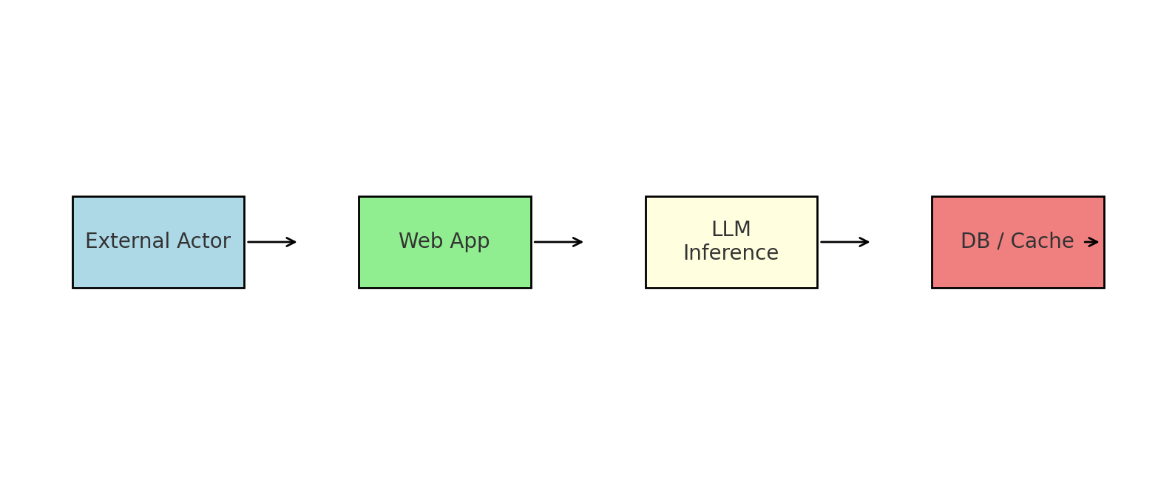

Figure 2: DFD

## 3.4 ER Diagram (Entities & Relationships)

* **User** (id, name, email, role, password_hash, date_joined)
* **Document** (id, owner_id, title, source_type, content_url, text, created_at)
* **Summary** (id, document_id, user_id, model, version, summary_text, created_at)
* **QuizItem** (id, document_id, type, stem, options, answer_key, explanation, difficulty, blooms_level)
* **QuizAttempt** (id, user_id, started_at, completed_at, score)
* **QuizResponse** (id, attempt_id, quiz_item_id, selected_option, is_correct)
* **PromptTemplate** (id, name, purpose, content)
* **ChatSession** (id, user_id, mode: homework/language, model, created_at)
* **ChatTurn** (id, session_id, role, content, tokens, timestamp)

## 3.5 Sequence Diagram – Quiz Generation

1. User selects document/topic.
2. Backend retrieves text and metadata.
3. Prompt template chosen based on target blooms level and question type.
4. Together API call generates candidate items.
5. Post-processing filters ambiguity, balances difficulty, checks answer keys.
6. Items saved; quiz assembled; user notified.

### Figure 4: Sequence Diagram

(Text-based description above; diagram to be added.)

## 3.6 Technology Stack

* **Backend:** Python 3.x, Django 5.x, Django REST Framework.
* **Auth:** Django allauth / SimpleJWT.
* **DB:** PostgreSQL (prod), SQLite (dev), Redis cache.
* **LLM:** Together APIs (text-generation, embeddings).
* **Parsing:** pdfminer/pytesseract for OCR as needed.
* **Testing:** pytest, factory_boy, coverage.
* **DevOps:** Docker, docker-compose, GitHub Actions CI, Black/Flake8, pre-commit.

## 3.7 Risk Management & Ethics

* **Fairness:** Avoid biased content via safety prompts and post-filters.
* **Privacy:** Minimize PII storage; encrypt at rest/in transit; allow data export/deletion.
* **Academic Integrity:** Homework chatbot gives hints and step-by-step thinking scaffolds, not just final answers; educator mode can reveal solutions for assessment design.
* **Cost Control:** Token budgets, caching summaries, nightly archiving.

# CHAPTER FOUR: SYSTEM ANALYSIS AND REQUIREMENT MODELLING

## 4.1 INTRODUCTION

This chapter presents a detailed analysis of the **SmartStudy system**. It explores the system’s functionalities, user interactions, data processes, and requirements. Using structured tools such as Data Flow Diagrams (DFDs), Flowcharts, and Entity-Relationship Diagrams (ERDs), the analysis highlights how learners, parents, and administrators interact with SmartStudy and how data flows through its core components.

## 4.2 SYSTEM FUNCTIONALITY

The SmartStudy system will support the following core functionalities:

**Student/Parent Functions:**

* User Registration/Login
* AI-Powered Smart Quiz Generator
* AI Summarizer for study materials
* Homework Assistant for instant help
* AI Chat & Voice Chat for learning support
* Study Planner (create & manage study plans)
* Question Generator (custom practice questions)
* Progress Tracking & Analytics

**Administrator Functions:**

* Admin Login via secure portal
* Manage users and accounts
* Manage AI modules and content (Quiz, Summarizer, etc.)
* Monitor platform usage and learning progress
* Moderate chat/voice interactions
* Generate system performance and learning analytics reports

## **4.3 USE CASE ANALYSIS**

**4.3.1 Use Case for Students/Parents/Teachers**

| **Use Case** | **Description** |
| --- | --- |
| Register/Login | User signs up or logs into their SmartStudy account |
| Generate Quiz | Users create AI-powered quizzes from chosen topics |
| Summarize Notes | Upload or input notes and receive concise AI summaries |
| Homework Help | Users ask questions and get instant AI assistance |
| Chat Support | Chat with AI or support for study help |
| Voice Chat | Voice-based interaction with AI tutor |
| Study Planning | Create/edit/view study schedules and milestones |
| Track Progress | View analytics on quizzes, tasks, and study sessions |

## **4.4 DATA FLOW DIAGRAMS (DFDs)**

## **4.4.1 Level 0 – Context Diagram**

**Processes:**

SmartStudy E-Learning System

**Entities:**

* Students/Parents
* Teachers
* AI Engines (Quiz Generator, Summarizer, Chatbot)
* External Resources (e.g., OpenAI, Together AI APIs)

This Level 0 Context Diagram shows how SmartStudy interacts with users, administrators, and external AI resources.

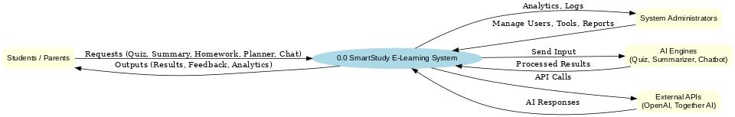

Figure 4.4.1 Level 0 – Context Diagram

## **4.4.2 Level 1 – Student Functionalities**

**Processes:**

* 1.1: Register/Login
* 1.2: Create Quiz
* 1.3: Summarize Content
* 1.4: Ask Homework Questions
* 1.5: Plan Study Sessions
* 1.6: View Progress & Reports
* 1.7: Chat/Voice Interaction

## **4.4.3 Level 2 – Quiz Generation Process**

**Processes:**

* 2.1: Input Topic / Upload Material
* 2.2: Process with AI Engine
* 2.3: Generate Quiz Questions
* 2.4: Display Quiz to User
* 2.5: Provide Instant Grading & Feedback

## **4.5 FLOWCHART**

**Main Flow (Student):**

1. User visits SmartStudy
2. Register/Login
3. Select a tool (Quiz Generator, Summarizer, Homework Help, Planner)
4. Input topic/material
5. System processes via AI engines
6. Output results (quiz, summary, answer, plan)
7. User reviews/acts on results
8. Progress recorded in analytics

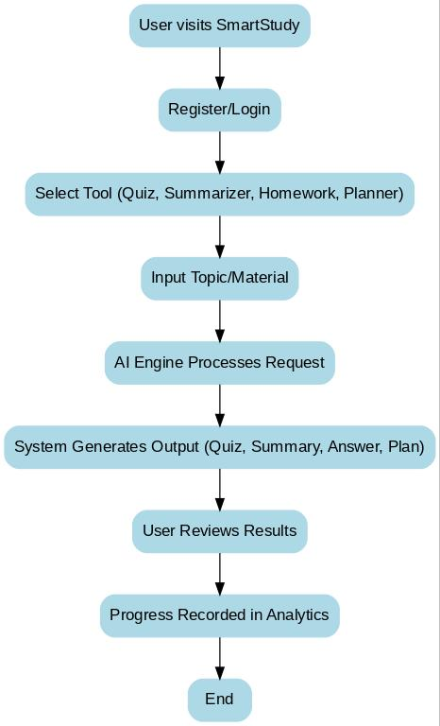

Figure Flowchat

## **4.6 ENTITY RELATIONSHIP DIAGRAM (ERD)**

**Entities:**

* Users (Students/Parents, Admins)
* Quizzes
* Notes/Summaries
* Homework Questions
* Study Plans
* Progress Reports
* Chats/Voice Sessions
* 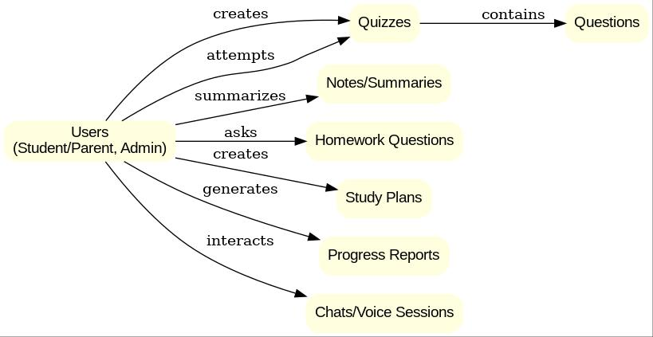

Figure Entity Relationship Diagram

**Key Relationships:**

* One user can create many quizzes, notes, and study plans
* One quiz belongs to one user but can have many questions
* Users generate multiple progress reports
* Users can have multiple chat/voice interactions
* Admin monitors multiple users

## **4.7 SYSTEM REQUIREMENTS**

### **4.7.1 Hardware Requirements**

| **Component** | **Minimum Requirement** |
| --- | --- |
| Processor | Intel Core i5 or equivalent |
| RAM | 8 GB |
| Storage | 256 GB SSD |
| Display | 1080p Resolution |
| Network | Stable broadband internet |
| Server | Cloud-based (with Python, Node.js, and AI API support) |

### **4.7.2 Functional Requirements**

* User registration and login system
* AI Quiz Generator (with instant grading)
* AI Summarizer for notes/documents
* Homework Assistant (Q&A system)
* Study Planner and Scheduler
* Real-time Chat & Voice Chat with AI tutor
* Progress Analytics and Reports module
* Secure Admin Portal for user and content management
* Integration with AI APIs (e.g., OpenAI, Together AI)

# **CHAPTER FIVE: SYSTEM DESIGN**

## **5.1 SYSTEM DESIGN OVERVIEW**

This chapter defines the architecture, components, modules, interfaces, and data flow of the **SmartStudy** system, implemented with **Django** (backend) and **Django Templates** (server-rendered frontend). The goal is a scalable, secure, and user-friendly platform that delivers AI-powered learning tools (Quiz Generator, Summarizer, Homework Help, Study Planner, Progress Analytics) and an admin back office.

### **5.1.1 Architectural Style**

SmartStudy follows Django’s **MTV pattern (Model–Template–View)**:

* **Model**: Python classes (ORM) mapping to relational tables (e.g., Users, Quizzes, Questions, Summaries, StudyPlans, Progress, Chats).
* **Template**: Server-rendered HTML using **Django Templates**, with template inheritance, includes, and filters.
* **View**: Django class-based views (CBVs) and function views that orchestrate requests, apply business logic/services, and return responses.

A **services layer** encapsulates AI calls (e.g., quiz generation, summarization) to keep views thin and testable.

### **5.1.2 Major Modules (Django Apps)**

1. **accounts/** – authentication, registration, roles (student/parent/admin), profiles.
2. **study/** – study planner, tasks, reminders.
3. **quiz/** – quiz generation, questions, attempts, grading, results.
4. **summarizer/** – note upload, text input, AI summaries, exports.
5. **homework/** – homework Q&A, solution steps, references.
6. **chat/** – AI chat & (optional) voice session logs.
7. **analytics/** – progress tracking, reports, dashboards.
8. **core/** – base templates, navigation, settings utilities, error pages.
9. **adminpanel/** – custom admin dashboards, moderation tools (built atop Django Admin + custom views).

### **5.1.3 Technology Stack**

* **Backend**: Django 5.x, Python 3.x
* **Frontend**: Django Templates, HTMX/Alpine.js (optional for snappy UX), vanilla JS
* **Database**: PostgreSQL (recommended) or MySQL
* **Cache/Session**: Redis (optional, for performance)
* **AI Integration**: Service layer calling AI APIs (e.g., OpenAI/Together) via HTTPS
* **Static/Media**: django-staticfiles + cloud storage (e.g., S3) for media
* **Auth**: Django auth, groups/permissions, optional social auth; JWT only if exposing APIs

### **5.1.4 Non-Functional Priorities**

* **Security**: CSRF protection, per-view permission checks, role-based access, rate limiting for AI endpoints, input validation, HTTPS, secure cookies, secrets in env.
* **Performance**: ORM select_related/prefetch_related, caching for read-heavy pages, async tasks (Celery/RQ) for long AI jobs, GZip, pagination.
* **Scalability**: Stateless app servers behind load balancer; separate worker queue for AI calls; database connection pooling.
* **UX**: Template inheritance, responsive layouts, accessible components, form validation, helpful error states.

### **5.2 INTERFACE DESIGN (Django Templates)**

SmartStudy uses **base.html** with {% block %} sections and component partials in **templates/partials/**. Pages inherit base and include shared header/footer/nav.

**Key Interfaces**  
1. **Home Dashboard (students/parents)**

* Quick actions (Quiz, Summarizer, Homework, Planner).
* Progress snapshot and recent activity.

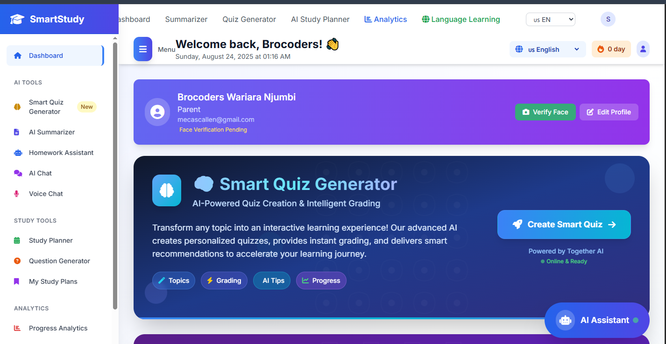

Figure Dashboard

ii. **Quiz Generator**

* Topic/subject input; difficulty, question types.
* Generated quiz preview → attempt → instant grading.
* 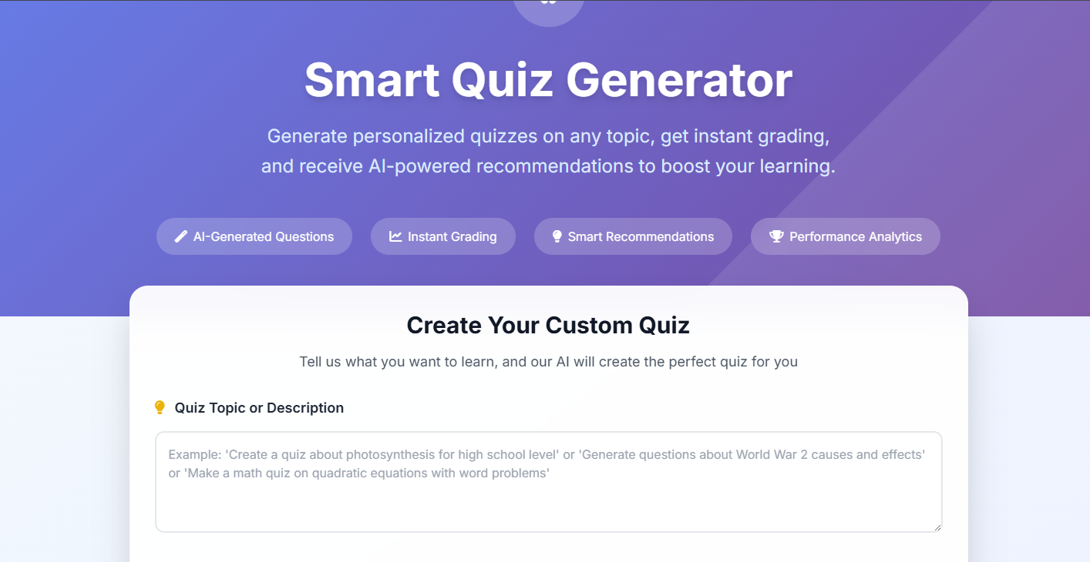

Figure Quiz Generator

iii. **Summarizer**

* Text area / file upload; AI summary with key points; export to PDF.

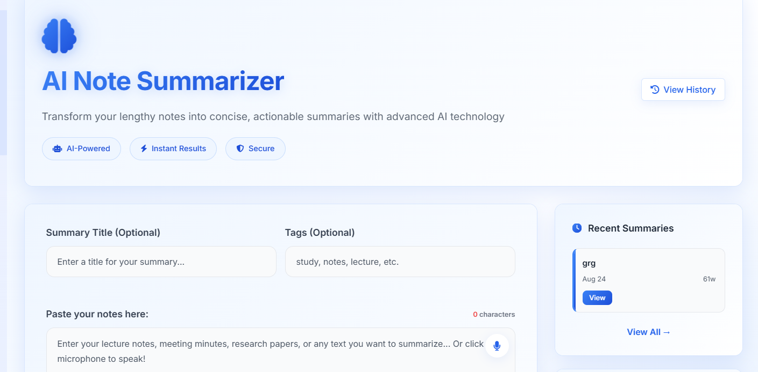

Figure Notes Summerizer

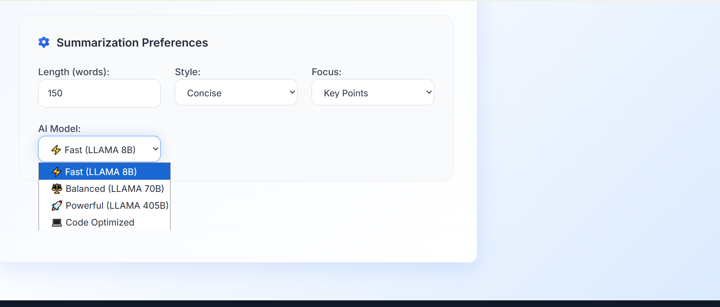

Figure summerizer preferences

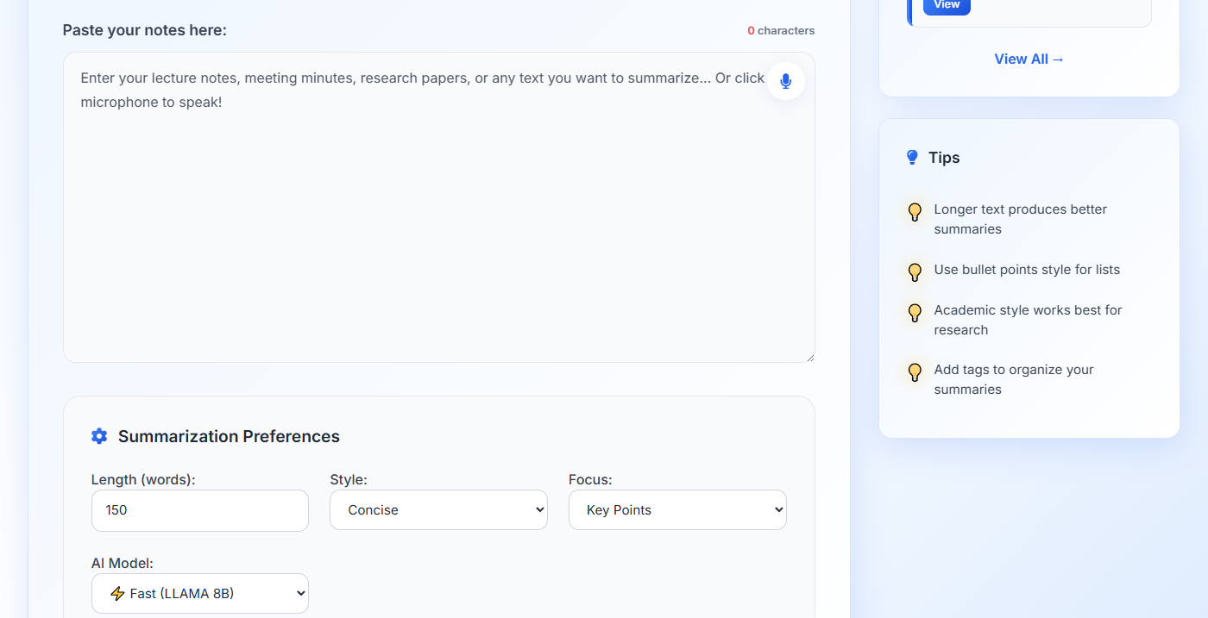iv. **Homework Help**

* Chat-style input → AI steps/solutions; cite references (if available). 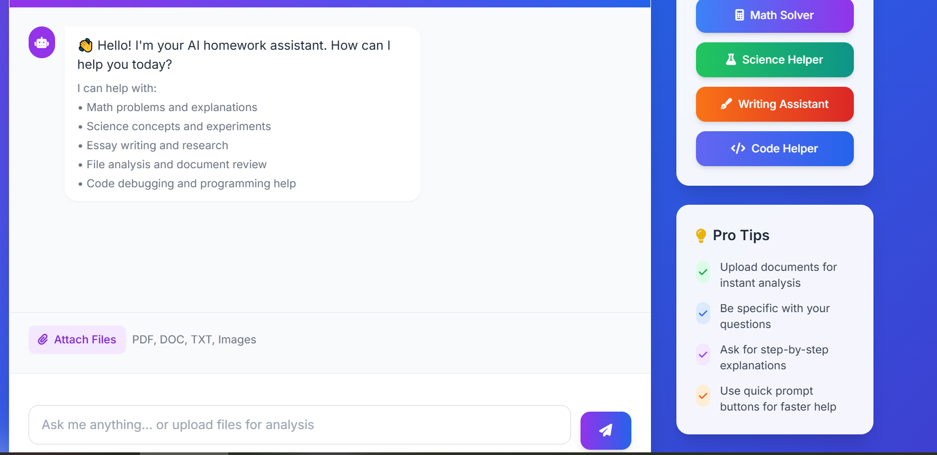

Figure Homework Assistant

v. **Study Planner**

* Calendar view, tasks, reminders, streaks.

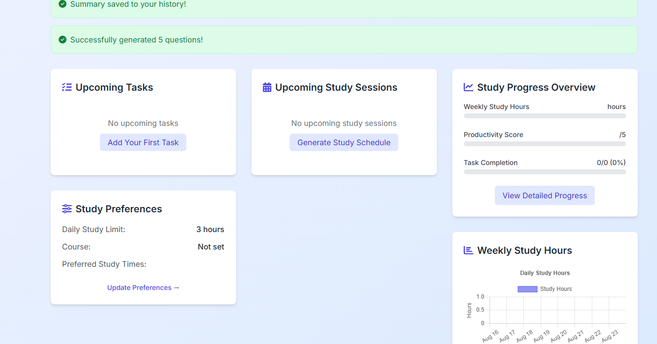

Figure Study Planner

vi. **Analytics & Reports**

* Charts (server-rendered data + JS charts).
* Downloadable reports.

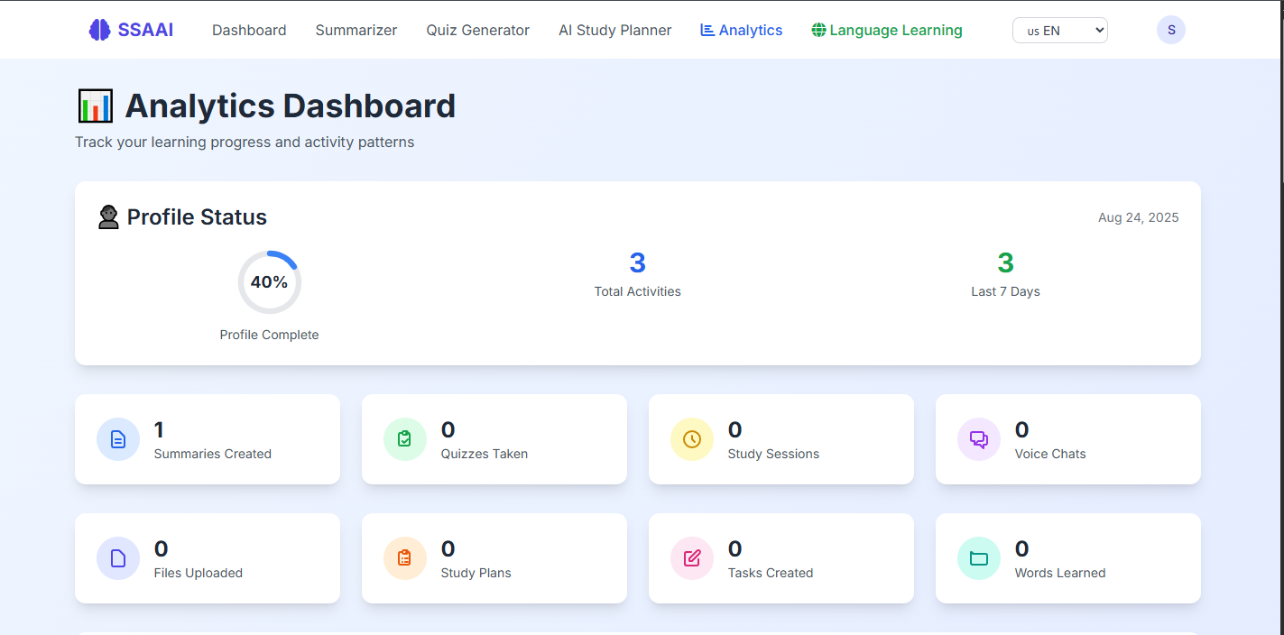

Figure Analytical Dashbaord

Project Settings

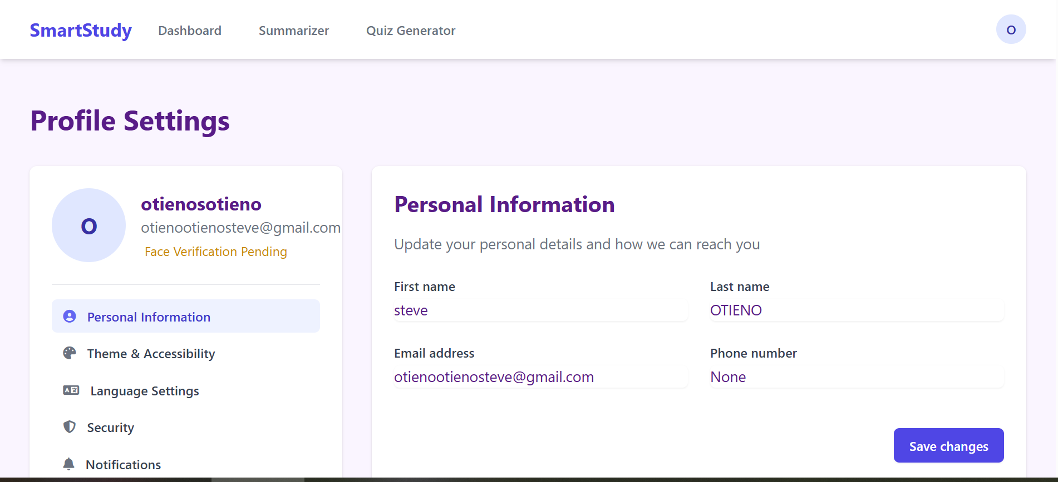

Figure Project settings



Figure Home work Chatbot

**5.3 DATABASE DESIGN**

**5.3.1 Conceptual Model (Entities)**

* **User** (role, profile)
* **Quiz**, **Question**, **QuizAttempt**, **AttemptAnswer**
* **Summary** (input text/document, output text)
* **HomeworkQuery** (question, answer, sources)
* **StudyPlan**, **StudyTask** (status, due dates)
* **ProgressReport** (aggregates per user)
* **ChatSession**, **ChatMessage** (AI interactions)

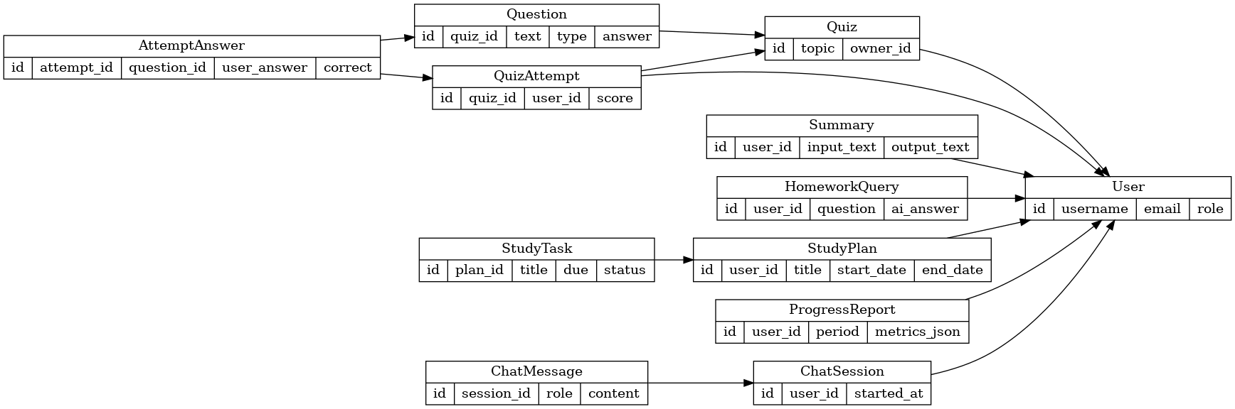

* accounts.User (AbstractUser or OneToOne profile with role)
* quiz.Quiz(topic, owner); quiz.Question(quiz, text, type, choices, answer)
* quiz.QuizAttempt(quiz, user, score, started_at, completed_at); quiz.AttemptAnswer(attempt, question, user_answer, correct)
* summarizer.Summary(user, source_type, input_text|file, output_text, created_at)
* homework.HomeworkQuery(user, question, ai_answer, created_at)
* study.StudyPlan(user, title, start_date, end_date); study.StudyTask(plan, title, due, status)
* analytics.ProgressReport(user, period, metrics_json)
* chat.ChatSession(user, started_at); chat.ChatMessage(session, role, content, created_at)

(Indexes on foreign keys, created_at, user_id; constraints for data integrity.)

**5.4 SECURITY & PERMISSIONS**

* Django auth groups: **student**, **parent**, **Teachers**.
* Decorators/mixins: LoginRequiredMixin, PermissionRequiredMixin.
* CSRF enabled on forms; form validation with Django Forms.
* File uploads: extension/size checks; virus scan hook (optional).

**5.5 DEPLOYMENT DESIGN**

* **Environment**: .env for secrets (DJANGO_SECRET_KEY, DB creds, AI keys).
* **Static/Media**: collectstatic to CDN; media to S3 (signed URLs).
* **Workers**: Celery + Redis for background AI tasks/exports.
* **Server**: gunicorn/uvicorn behind Nginx; HTTPS (Let’s Encrypt).

# **CHAPTER SIX: SYSTEM IMPLEMENTATION**

## **6.1 Introduction**

System implementation refers to the process of translating the system design specifications into a fully operational and functional software product. It marks the transition from theoretical and architectural blueprints to a usable, interactive, and deployable platform. This phase is crucial because it validates whether the proposed solution is technically feasible, user-friendly, and capable of meeting the identified requirements.

In the case of the SmartStudy platform, implementation was carried out using a modular and iterative development methodology. Each module—namely, the frontend, backend, database, and the AI-powered recommendation engine—was developed independently and then progressively integrated. This approach ensured that bugs and errors could be identified and corrected early, while also allowing for scalability and continuous improvement.

The implementation of the SmartStudy system was guided by four core principles:

* Reliability: Ensuring the system is stable, minimizes downtime, and consistently delivers accurate results even under heavy loads.
* Scalability: Designing the platform to support growth, both in terms of user numbers and learning content.
* Security: Protecting user data through secure authentication, encrypted sessions, and privacy-preserving mechanisms.
* User Experience (UX): Creating an intuitive, interactive, and responsive interface that enhances usability and accessibility for learners of diverse backgrounds.

This chapter provides an in-depth description of the programming tools, frameworks, and technologies adopted in the implementation of SmartStudy, along with details of the deployment environment and version control mechanisms used.

## **6.2 Coding Tools, Programming Languages, and Frameworks**

The successful implementation of SmartStudy relied on a carefully selected technology stack, combining both backend and frontend tools, as well as modern AI integration APIs. The following technologies were used:

**Python (Django Framework)**

Python was the primary programming language for the backend due to its simplicity, robustness, and strong ecosystem of libraries. The Django framework was chosen because it provides:

* A Model-View-Controller (MVC) architectural pattern, which supports modularity and maintainability.
* Django ORM (Object Relational Mapping) to simplify interactions with the database, eliminating the need for raw SQL queries.
* Built-in features such as authentication, form handling, and session management, which enhanced security and reduced development overhead.
* Scalability, making it suitable for handling growing user requests and content in the future.

**HTML5, CSS3, and JavaScript (Django Templates)**

The frontend interface was implemented using standard web technologies:

* HTML5 provided semantic structure for web pages and ensured accessibility.
* CSS3 was used to design and style the application, with a focus on responsiveness across multiple devices (desktop, tablet, mobile).
* JavaScript, supported by AJAX, was integrated to add interactivity, real-time updates, and smooth transitions between learning resources.
* Django templates facilitated seamless integration of frontend pages with backend logic.

**PostgreSQL Database**

The system’s structured data—such as user profiles, courses, quizzes, study sessions, AI chat logs, and payment transactions—was stored in PostgreSQL. The choice of PostgreSQL was influenced by its:

* High performance in handling large volumes of data.
* Support for advanced queries, indexing, and scalability.
* Strong security features, including role-based authentication and data integrity enforcement.
* Compatibility with Django ORM.

Bootstrap & TailwindCSS

For rapid UI development and responsiveness:

* Bootstrap provided prebuilt components such as navigation bars, forms, and modals, which reduced development time.
* TailwindCSS allowed for utility-first styling, offering greater flexibility in customizing layouts and achieving a modern, clean design.  
  The combination of both frameworks ensured consistency, responsiveness, and a visually appealing user interface.

**Dialogflow & OpenAI API**

To integrate artificial intelligence features, the system connected to external APIs:

* Dialogflow was used for building conversational agents that guide learners through FAQs, quizzes, and personalized recommendations.
* OpenAI API enabled advanced natural language processing for summarization, question generation, and providing real-time study assistance in multiple languages.  
  These AI features positioned SmartStudy as an intelligent, adaptive learning companion.

**Git & GitHub**

Version control was managed using Git. The repository was hosted on GitHub, enabling:

* Team collaboration through branching, merging, and pull requests.
* Tracking of code changes and rollback in case of errors.
* Continuous integration and smooth deployment workflows.

**Deployment Environment**

For deployment and hosting, the following technologies were adopted:

* Apache / Nginx servers with Gunicorn for serving Django applications in a production environment.
* DigitalOcean and Heroku were considered for cloud hosting due to their scalability, ease of deployment, and cost-effectiveness.
* Docker containers (optional) were used during testing to ensure consistency across development, staging, and production environments.

## **6.3 Summary**

The implementation of SmartStudy was achieved through the combination of powerful backend technologies (Django, Python, PostgreSQL), flexible and responsive frontend frameworks (HTML5, CSS3, JavaScript, Bootstrap, TailwindCSS), and cutting-edge AI tools (Dialogflow, OpenAI API). The use of version control (GitHub) and modern deployment environments (Heroku/DigitalOcean) ensured that the platform was stable, maintainable, and scalable.

By following an iterative and modular implementation process, the system was able to integrate all key modules effectively, leading to a robust AI-assisted learning platform capable of meeting the educational needs of students and educators alike.

# **CHAPTER SEVEN: LIMITATIONS, CONCLUSIONS, AND RECOMMENDATIONS**

## **7.1 Limitations**

While the SmartStudy system was successfully developed and deployed in a functional state, a number of limitations were identified during the testing and evaluation phase. These limitations highlight the practical challenges that need to be addressed in order to scale and improve the system:

1. **Limited Scalability in Free Hosting Plans**  
   The system can run smoothly under light usage conditions; however, when deployed on free or entry-level hosting environments (such as shared servers or trial cloud plans), performance may degrade significantly. High traffic, multiple concurrent users, or large-scale file uploads can lead to delays, slow page rendering, or even downtime. Scaling to enterprise-level usage requires more robust cloud infrastructure with auto-scaling features.
2. **AI Chatbot Accuracy**  
   Although the integrated AI chatbot offers real-time support, it is not immune to limitations in accuracy. On certain occasions, the chatbot may provide overly generic responses or misunderstand context-specific queries. This is largely due to dataset limitations and lack of domain-specific training. While suitable for general study support, the AI assistant requires further refinement to reach expert-level accuracy.
3. **Mobile Optimization Challenges**  
   The system was built to be responsive using frameworks such as Bootstrap and TailwindCSS; however, extensive testing revealed that some interactive features—such as quiz interfaces, drag-and-drop elements, or embedded multimedia—do not display consistently across different mobile devices and screen resolutions. This presents usability challenges for students who primarily access the system via mobile phones.
4. **Dependency on Internet Connectivity**  
   As a fully web-based solution, SmartStudy relies on constant and stable internet connectivity. Students in areas with poor network infrastructure may face difficulties accessing the platform, particularly during real-time interactions such as video sessions or chatbot conversations. This limitation reduces the platform’s inclusivity for learners in rural or underprivileged areas.
5. **Integration Costs**  
   The integration of advanced AI models (e.g., OpenAI API) and secure payment gateways introduces recurring costs that may not be affordable for smaller institutions or individual users. Scaling the system to handle larger datasets or advanced personalization also incurs additional infrastructure expenses, making cost a limiting factor for widespread adoption.
6. **User Training Requirements**  
   Some users, especially those unfamiliar with e-learning platforms, may require training to effectively use all features of SmartStudy. For example, navigating dashboards, accessing quiz modules, or interacting with the chatbot may not be intuitive for first-time users, particularly in regions with limited digital literacy.
7. **Data Privacy Concerns**  
   Since the system collects and stores sensitive data such as user profiles, course history, and payment records, it is subject to data protection regulations (e.g., GDPR). In its current form, the system implements basic encryption and authentication, but advanced compliance measures such as data anonymization and user-controlled consent mechanisms are still in development.

## **7.2 Conclusion**

The **SmartStudy system** represents a successful attempt to integrate **artificial intelligence, online learning resources, and interactive study tools** into a unified digital platform. The system provides learners with access to course materials, quizzes, real-time AI-assisted support, and administrative management features within a single, easy-to-navigate interface.

Key achievements of the project include:

* The successful adoption of **Django backend** and **PostgreSQL database** to build a robust and scalable system architecture.
* A **responsive and modular frontend design** using HTML5, CSS3, JavaScript, Bootstrap, and TailwindCSS.
* The integration of **AI-powered features** such as chatbots, summarization, and intelligent recommendations to improve study efficiency and personalization.
* Implementation of **basic security features** (authentication, password hashing, role-based access) that safeguard user data.

The project also demonstrates the potential of AI-powered e-learning systems to address gaps in traditional education. By enhancing accessibility, enabling real-time feedback, and offering interactive study options, SmartStudy aligns with the global shift toward digital learning.

Most importantly, the **modular architecture** ensures that the platform can evolve over time. Future enhancements—such as integration with mobile applications, advanced analytics dashboards, multilingual support, and institutional-level adoption—can be implemented without disrupting the existing structure.

In conclusion, SmartStudy highlights the **transformative role of AI in education**, making learning more **accessible, engaging, and scalable**, while also providing a foundation for future academic and commercial expansion.

## **7.3 Recommendations**

Based on the limitations encountered and the feedback received during system testing, the following recommendations are made for the improvement and future expansion of the SmartStudy platform:

1. **Mobile App Development**  
   Develop **native Android and iOS applications** to ensure broader accessibility and smoother mobile experiences. Mobile apps would support offline caching, push notifications, and improved usability for learners who primarily rely on smartphones.
2. **AI Personalization Enhancements**  
   Enhance chatbot accuracy and adaptability by training it on **domain-specific datasets** (e.g., STEM subjects, humanities). Personalization can also be improved by integrating adaptive learning algorithms that adjust difficulty levels and suggest study materials based on individual performance.
3. **Offline Features**  
   Introduce **offline access modes** where learners can download course materials, quizzes, and notes for later use without internet connectivity. Synchronization mechanisms should ensure progress updates once connectivity is restored.
4. **Gamification**  
   Integrate **gamified features** such as leaderboards, point systems, digital badges, and rewards to foster engagement and motivation among students. Gamification has been proven to increase learner retention and encourage peer-to-peer competition.
5. **Institutional Integration**  
   Collaborate with **schools, universities, and training institutions** for real-world adoption. This would involve integration with existing Learning Management Systems (LMS) such as Moodle or Blackboard, ensuring compatibility and ease of transition for institutions.
6. **Security Enhancements**  
   Strengthen security through the implementation of:
   * **Two-Factor Authentication (2FA)** for user logins.
   * **Periodic penetration testing** to identify vulnerabilities.
   * **Data encryption at rest and in transit** using advanced cryptographic protocols.
   * **Role-based access control (RBAC)** to manage permissions across different users (students, lecturers, administrators).
7. **Advanced Analytics and Reporting**  
   Implement an **AI-driven analytics dashboard** for both students and administrators. Students could receive insights into their learning progress, while institutions could analyze aggregated data for curriculum improvements and performance evaluation.
8. **Multilingual and Accessibility Support**  
   Broaden inclusivity by adding **multilingual support** and **AI-powered sign language interpretation** for students with disabilities. This would align the system with global accessibility standards and enhance adoption across diverse regions.
9. **Cost Optimization Strategies**  
   Explore **open-source AI alternatives** or deploy AI models on **custom-trained servers** to reduce reliance on costly third-party APIs. This would make the system more affordable for small institutions and individuals.
10. **Continuous User Training and Support**  
    Provide **onboarding tutorials, help centers, and demo videos** to ensure that new users can navigate the platform effectively. Additionally, establish customer support channels for addressing technical and learning challenges.

# **References**

1. Alshammari, S.H. and Qtaishat, D.S., 2020. The role of e-learning platforms in enhancing education outcomes. *International Journal of Emerging Technologies in Learning*, 15(20), pp.172–187. doi:10.3991/ijet.v15i20.15799.
2. Anderson, T. and Dron, J., 2011. Three generations of distance education pedagogy. *International Review of Research in Open and Distributed Learning*, 12(3), pp.80–97. doi:10.19173/irrodl.v12i3.890.
3. Azevedo, R. and Aleven, V. (eds.), 2013. *International handbook of metacognition and learning technologies*. Springer. doi:10.1007/978-1-4419-5546-3.
4. Bates, A.W., 2019. *Teaching in a digital age: Guidelines for designing teaching and learning*. Tony Bates Associates. Available at: <https://pressbooks.bccampus.ca> [Accessed 25 August 2025].
5. Bernard, R.M., Borokhovski, E., Schmid, R.F., Tamim, R.M. and Abrami, P.C., 2014. A meta-analysis of blended learning and technology use in higher education. *Educational Research Review*, 9, pp.124–140. doi:10.1016/j.edurev.2014.10.002.
6. Cerny, T., Donahoo, M.J. and Trnka, M., 2018. Contextual understanding of microservice architecture: Current and future directions. *ACM SIGAPP Applied Computing Review*, 17(4), pp.29–45. doi:10.1145/3183765.3183769.
7. Chen, C.M. and Duh, L.J., 2018. Personalized web-based tutoring system based on learning style and cognitive theory. *Interactive Learning Environments*, 26(3), pp.327–345. doi:10.1080/10494820.2017.1283338.
8. Django Software Foundation, 2023. *Django documentation*. Available at: <https://docs.djangoproject.com> [Accessed 25 August 2025].
9. Hrastinski, S., 2008. Asynchronous and synchronous e-learning. *Educause Quarterly*, 31(4), pp.51–55. Available at: <https://er.educause.edu> [Accessed 25 August 2025].
10. Huang, R., Spector, J.M. and Yang, J., 2019. *Educational technology: A primer for the 21st century*. Springer. doi:10.1007/978-981-13-6643-7.
11. Iftikhar, N. and Danish, M., 2021. Web-based learning systems: Comparative analysis of frameworks and technologies. *Education and Information Technologies*, 26(6), pp.7653–7673. doi:10.1007/s10639-021-10637-5.
12. Johnson, L., Becker, S.A., Estrada, V. and Freeman, A., 2015. *The NMC horizon report: 2015 higher education edition*. The New Media Consortium. Available at: <https://library.educause.edu> [Accessed 25 August 2025].
13. Kintu, M.J., Zhu, C. and Kagambe, E., 2017. Blended learning effectiveness: The relationship between student characteristics, design features and outcomes. *International Journal of Educational Technology in Higher Education*, 14(1), p.7. doi:10.1186/s41239-017-0043-4.
14. Laurillard, D., 2013. *Teaching as a design science: Building pedagogical patterns for learning and technology*. Routledge.
15. Li, J. and Wong, G.K.W., 2021. How artificial intelligence reshapes e-learning. *Computers & Education*, 168, p.104202. doi:10.1016/j.compedu.2021.104202.
16. Moore, J.L., Dickson-Deane, C. and Galyen, K., 2011. E-learning, online learning, and distance learning environments: Are they the same? *Internet and Higher Education*, 14(2), pp.129–135. doi:10.1016/j.iheduc.2010.10.001.
17. OECD, 2020. *The impact of AI on education*. OECD Publishing. Available at: <https://www.oecd.org> [Accessed 25 August 2025].
18. Panigrahi, R., Srivastava, P.R. and Sharma, D., 2018. Online learning: Adoption, continuance, and learning outcome—A review of literature. *International Journal of Information Management*, 43, pp.1–14. doi:10.1016/j.ijinfomgt.2018.05.005.
19. Picciano, A.G., 2017. Theories and frameworks for online education: Seeking an integrated model. *Online Learning*, 21(3), pp.166–190. doi:10.24059/olj.v21i3.1225.
20. Zawacki-Richter, O., Marín, V.I., Bond, M. and Gouverneur, F., 2019. Systematic review of research on artificial intelligence applications in higher education. *International Journal of Educational Technology in Higher Education*, 16(1), p.39. doi:10.1186/s41239-019-0171-0.